Co-production Evidence Log
This document is for collecting information about a time you were listened to………
It is to evidence good practice and show when young people have been listened to across the area. Evidence will be shared via the local offer, governance boards and maybe used for the joint local area inspection.

Summary of experience. Please give a short overview of the time you were listened to. This is the important information that lets others know what happened.



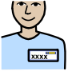

Details of listener
If you know them
Name Email Phone


What did you discuss?

Happy?



Others involved (numbers, age range, additional needs etc.)



What did they ask?



What you and/or other young people said?



Did anything change? What decisions have been made?

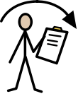


Has there been follow up?
No
Yes



How did this experience feel?

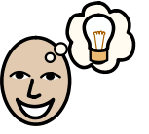
What important things have you learnt from this experience?

Your details!

Name

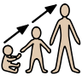

Age

Contact information

